**Pizza Sales SQL Queries:**

Initial insights from the data

1. **Pizza categories**

select distinct pizza_category from pizza_sales;

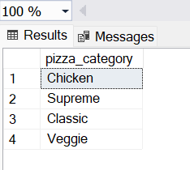

1. **Different pizza sizes**

select distinct pizza_size from pizza_sales;

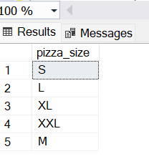

1. **Total orders**

select count(distinct order_id) as count_of_orders from pizza_sales;

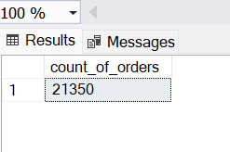

1. **Total variety of Pizzas**

select count(distinct pizza_name) as total_variety_of_pizzas from pizza_sales;

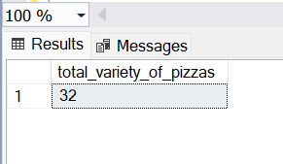

**KPIs:**

1. **Total Revenue:**

select sum(total_price) as total_revenue

from pizza_sales;

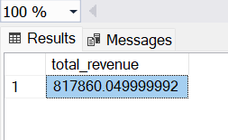

1. **Average order value**

select sum(total_price)/count(distinct order_id) as avg_order_value

from pizza_sales;

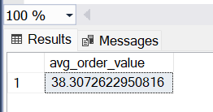

1. **Total pizzas sold**

select sum(quantity) as total_pizzas_sold

from pizza_sales;

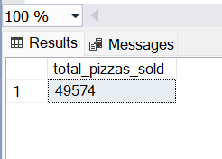

1. **Total orders**

select count(distinct order_id) as total_orders from pizza_sales;

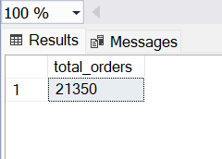

1. **Average pizzas per order**

select round(sum(quantity)/count(distinct order_id),2) as avg_pizza_per_order from pizza_sales;

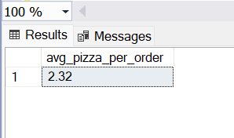

1. **Hourly Trend of pizzas sold:**

select datepart(hour, order_time) as hour, sum(quantity) as no_of_pizzas_sold_per_hour

from pizza_sales

group by datepart(hour, order_time)

order by hour;

**Output:**

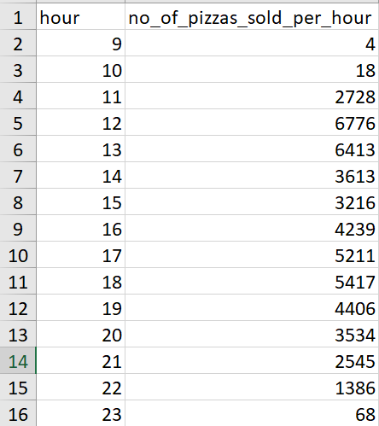

1. **Weekly trend of orders**

select datepart(year, order_date) as year, datepart(week, order_date) as week, count(distinct order_id) as total_orders

from pizza_sales

group by datepart(week, order_date), datepart(year, order_date)

order by year, week;

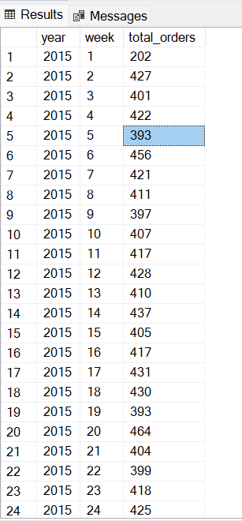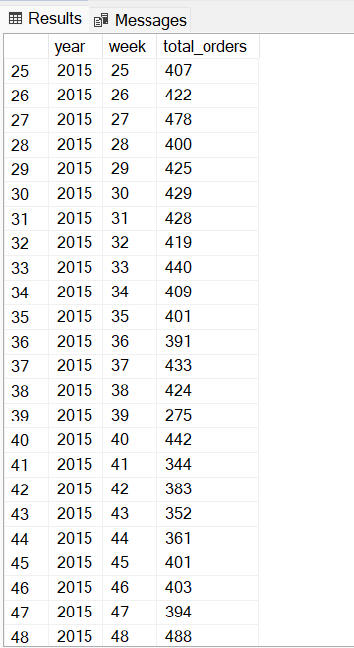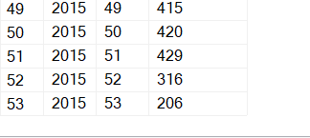

1. **% of sales by pizza category**

select pizza_category, revenue, round((revenue/total_revenue)*100,2) as perc_of_sales

from

(

select pizza_category, round(sum(total_price),2) as revenue, (select round(sum(total_price),2) from pizza_sales) as total_revenue

from pizza_sales

group by pizza_category

) m;

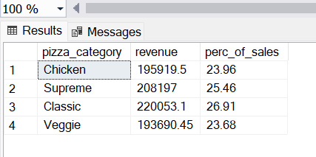

1. **% of sales by pizza size**

select pizza_size, revenue, round((revenue/total_revenue)*100,2) as perc_of_sales

from

(

select pizza_size, round(sum(total_price),2) as revenue, (select round(sum(total_price),2) from pizza_sales) as total_revenue

from pizza_sales

group by pizza_size

) m;

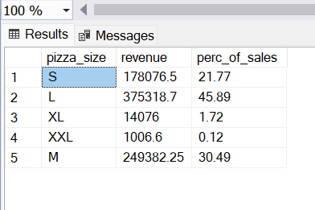

1. **Total pizzas sold by pizza_category**

select pizza_category , sum(quantity) as total_pizzas_sold

from pizza_sales

group by pizza_category

order by total_pizzas_sold desc;

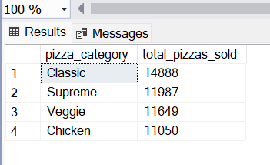

1. **Top 5 pizzas by revenue**

select pizza_name, revenue

from

(

select pizza_name, sum(total_price) as revenue,

dense_rank() over (order by sum(total_price) desc) as rank

from pizza_sales

group by pizza_name

) m

where rank <=5;

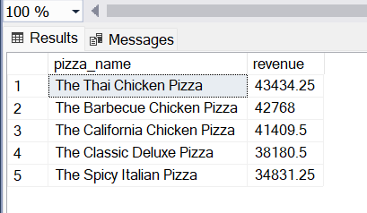

1. **Bottom 5 pizzas by revenue**

select pizza_name, revenue

from

(

select pizza_name, sum(total_price) as revenue,

dense_rank() over (order by sum(total_price) asc) as rank

from pizza_sales

group by pizza_name

) m

where rank <=5;

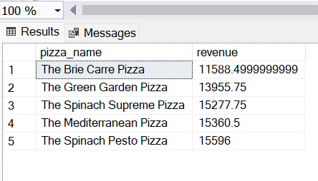

1. **Top 5 pizzas by quantity**

select pizza_name, total_quantity

from

(

select pizza_name, sum(quantity) as total_quantity,

dense_rank() over (order by sum(quantity) desc) as rank

from pizza_sales

group by pizza_name

) m

where rank <=5;

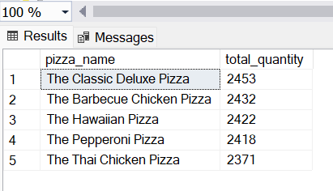

1. **Bottom 5 pizzas by quantity**

select pizza_name, total_quantity

from

(

select pizza_name, sum(quantity) as total_quantity,

dense_rank() over (order by sum(quantity) asc) as rank

from pizza_sales

group by pizza_name

) m

where rank <=5;

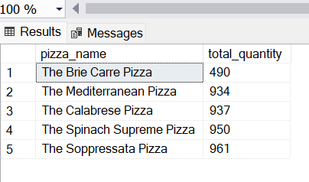

1. **Top 5 Pizzas by total_orders**

select pizza_name, total_orders

from

(

select pizza_name, count(distinct order_id) as total_orders,

dense_rank() over(order by count (distinct order_id) desc) as rank

from pizza_sales

group by pizza_name

) m

where rank <=5;

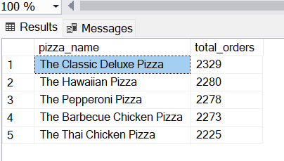

1. **Bottom 5 Pizzas by total_orders**

select top 5 pizza_name, count(distinct order_id) as total_orders

from pizza_sales

group by pizza_name

order by total_orders asc;

